Q1)

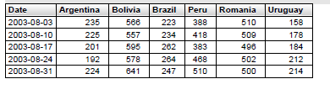

Q2)

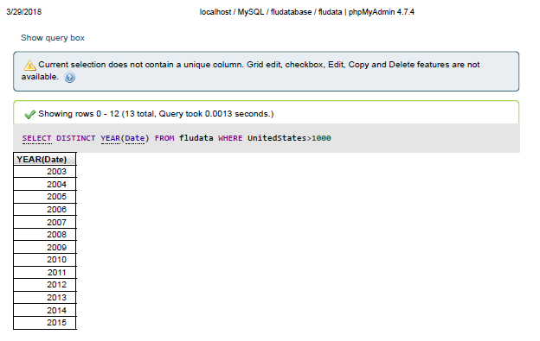

Q3)

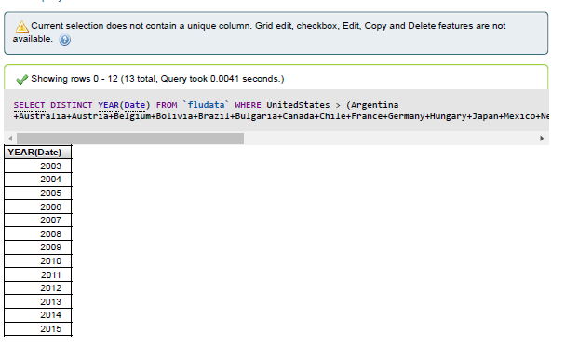

Q4)

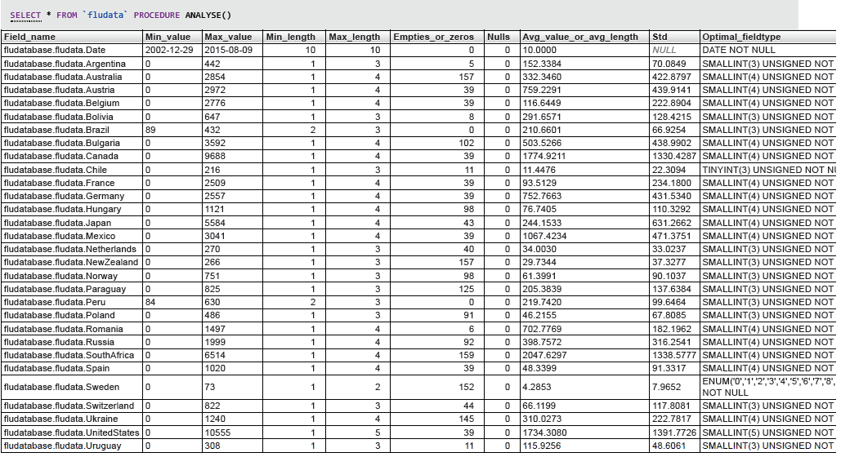

Q5)



From the above table and data set we can say that flu originate at Brazil and Bolivia.